Medicine System
Overview
The Medicine System is a simple console-based Python app that helps people keep track of their daily medicines. It is especially useful for elderly users or patients who often forget doses, which can affect their recovery and overall health. The program lets users add medicines, view their schedule, mark doses as taken, and see what is still pending.
Problem Addressed
Many people, particularly older adults and patients on multiple medications, struggle to remember what to take and when. Missing doses can lead to:
- Worsening health or slow recovery
- Serious issues if critical medicines are skipped
- Confusion about which medicines were taken and at what time
- Poor treatment results over the long term
This project offers a simple digital helper that keeps everything organised and supports a regular medication routine.
Main Features
- Add New Medicine – Save medicines with an ID, name, dosage, and timing details.
- View All Medicines – See a full list of all medicines and their information.
- Search Medicine – Quickly find a medicine by ID or name without worrying about letter case.
- Mark as Taken – Mark a medicine as taken and record the exact date and time automatically.
- Today’s Schedule – View all medicines scheduled for today with a clear taken/pending status.
- Delete Medicine – Remove medicines that you no longer need.
- Data Persistence – All data is stored in an Excel file and loaded back when the program starts.
- Input Validation – Handles wrong inputs gracefully and shows clear error messages.
Python Concepts Used
Data Structures
- A list (medicines = []) holds all medicine records.
- Each medicine is a dictionary with fields like id, name, dosage, time_of_day, time, status, and last_taken.
- This creates a clean “list of dictionaries” structure that is easy to search and update.
Control Flow
- A while loop keeps the main menu running until the user chooses to exit.
- for loops are used to go through the list of medicines for displaying, searching, and checking schedules.
- Multiple if/elif/else blocks handle menu choices, input validation, and logic such as checking if a medicine is active or already taken today.
Functions
The program is broken into small, focused functions:
- display_all_meds() – Show all medicines.
- search_med() – Search for a specific medicine.
- add_medicine() – Add a new medicine.
- update_taken_status() – Mark a medicine as taken.
- check_schedule() – Show today’s schedule and taken/pending status.
- remove_medicine() – Delete a medicine.
- load_data() – Load data from the Excel file.
- save_data() – Save data back to the Excel file.
- show_menu() – Display the main menu.
Methods and String Handling
- List methods:
  - append() to add medicines and IDs.
  - remove() to delete medicines from the list.
- Dictionary methods:
  - get() to safely fetch values.
  - update() to refresh fields like last_taken.
- String methods:
  - upper() and lower() for case-insensitive search and confirmations.
  - split() to extract the date part from timestamps.
  - ljust() and str() to format and display output neatly.
Exception Handling
The program uses try/except blocks to:
- Catch invalid menu inputs (for example, when a user types text instead of a number).
- Handle file errors when loading or saving data.
- Deal with unexpected issues without crashing the program.
File Handling and Libraries
- Uses an Excel file medicine.xlsx to store all medicine records.
- On startup, the program loads data from this file if it exists; otherwise, it starts with an empty list.
- On exit (option 7), it saves all changes back to the same Excel file.
- Uses:
  - pandas for reading and writing Excel files.
  - datetime to generate timestamps when medicines are marked as taken.
  - openpyxl as the engine behind Excel operations via pandas.
How to Run
Requirements
- Python 3.6 or higher
- Jupyter Notebook
- Libraries: pandas, openpyxl
Install the libraries:
pip install pandas openpyxl
Steps
- Download:
  - medicine_reminder.ipynb
  - medicine.xlsx
- Put both files in the same folder.
- Open Jupyter Notebook:
jupyter notebook
- Open medicine_reminder.ipynb.
- Run all cells or the main program cell.
- The program will load existing data (if any) and show the main menu.
Input and Usage Guidelines
Adding a Medicine
- Medicine ID: Use unique codes like MED001, MED002, etc.
- Name: Any valid medicine name (e.g., Paracetamol, Aspirin).
- Dosage: Include units (e.g., 500mg, 10ml, 2 tablets).
- Time of Day: Morning, Afternoon, Evening, or Night.
- Time: 12‑hour format with AM/PM (e.g., 08:00 AM, 10:30 PM).
Navigating the Menu
- Enter a number from 1 to 7 to choose an option.
- If you type something invalid, the program shows an error and asks again.
- Always use option 7 “Save and Exit” to store your changes properly.
Searching and Marking
- Search by ID or name; the search is case-insensitive and supports partial matches.
- When marking a medicine as taken, enter its exact ID.
- The system records the current date and time and updates the schedule view.
File and Dataset Details
- Data file: medicine.xlsx (stored in the same folder as the notebook).
- If the file is missing, the program starts with no records and creates the file when you save.
- Columns include: id, name, dosage, time_of_day, time, status, last_taken.
The project can ship with a sample medicine.xlsx containing around 20 realistic entries (pain relief, vitamins, antibiotics, chronic condition medicines, etc.) so you can test all features immediately without manual entry.
Testing and Screenshots
Useful test scenarios:
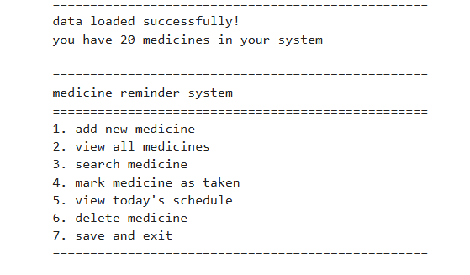
- Viewing all medicines.
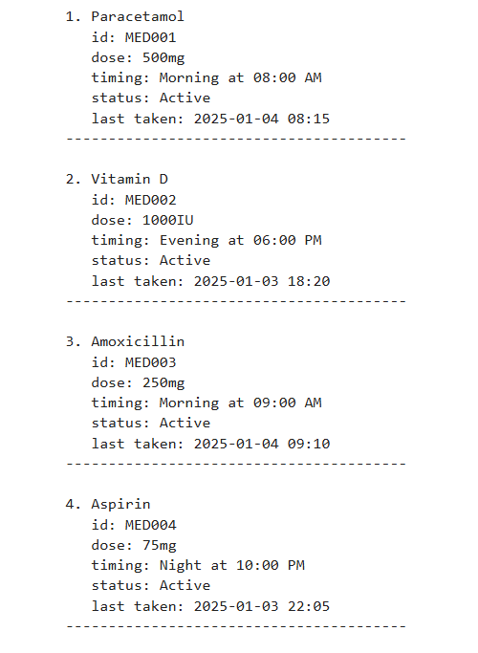
- Checking today’s schedule to see taken vs pending.

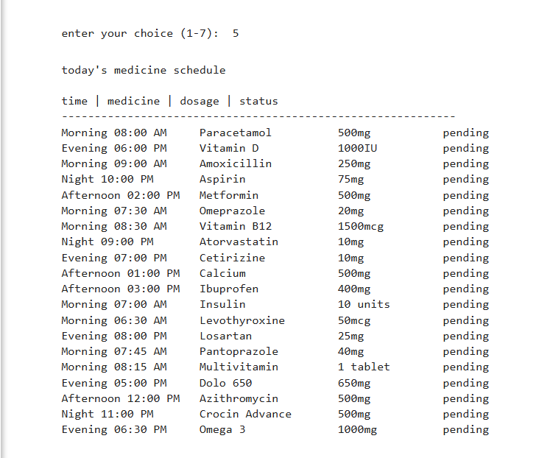
- Searching by partial name (e.g., “Vitamin”) or specific ID (e.g., “MED001”).
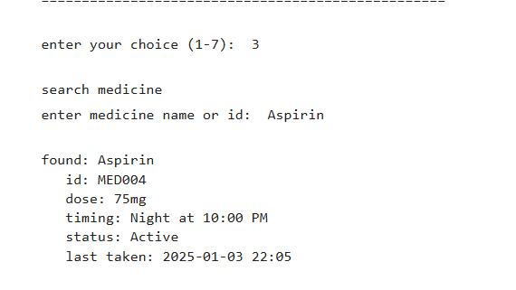
- Marking a medicine that has last_taken = "Never" and confirming it updates.
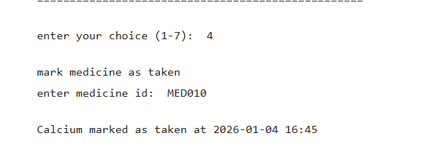
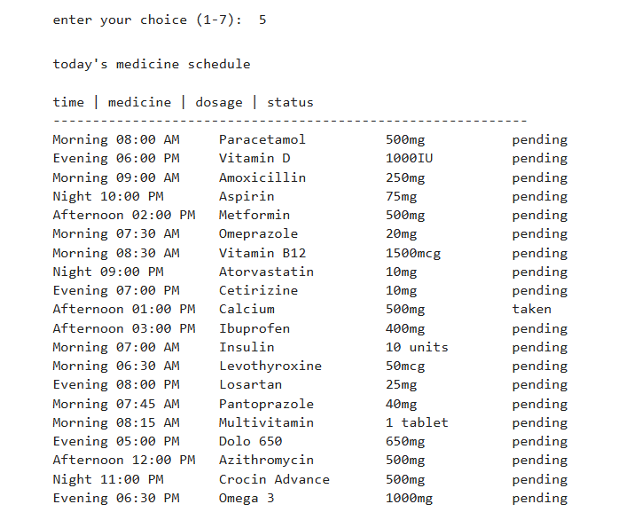
- Adding a new medicine and then viewing the list.
- Deleting a medicine and verifying it is removed.
- Saving, restarting, and confirming data persists.
For documentation, take screenshots of startup, menu, viewing medicines, today’s schedule, search results, adding, marking taken, and saving.
Assignment Fit and Extras
This project:
- Solves a clear, real-world problem.
- Uses a list of dictionaries for data storage.
- Is fully menu-driven with a while loop.
- Has more than the required number of functions and conditionals.
- Uses list, dictionary, and string methods.
- Includes multiple try/except blocks.
- Implements file handling with Excel via pandas.
- Can include a preloaded dataset for easy demonstration.
Author and Project Info
- Name: L Hemachandan
- USN: 1BG24BA057
- Course: Python Programming
- Project: Medicine Reminder System
- Domain: Healthcare – Medicine Tracking

